

Holly’s Paw Print’s Factory

[Document subtitle]



[Date]

Home

[Company address]

# Appendix

Table of Contents

Introduction: 0

Issue: 0

Proposed solution: 1

Database design model: 1

Table details 1

Customer_details: 1

pet_details 2

Inventory: 2

Order details: 3

Offers: 4

Conclusion 6

Introduction:

Holly’s Paw Print’s Factory is a start-up company that is a worldwide supplier of boutique dog products. Which maintains the customer’s records such as name, contact information, pet information, available inventory, order details and provide the offer to the customer on the different-different occasion.

Issue:

As the business grows, and the number of products and the customer’s traffic will increase, then there will be difficult to maintain the records of the customer details, pet’s detail, inventory, and products, etc. It requires lots of time to manage these records, and if the number of the file gets increase then it will be very difficult to make the track of the particular customer.

### Proposed solution:

It requires a database, where we can maintain the records of the required details. It will easy to manage the business which will save them lots of time, which can be utilized to improve the productivity of the company.

### Database design model:

The entity-relationship diagram of the database is given below, which elaborates about the customer order and the inventory details, order details pet’s details, and the offer thrown by the company.

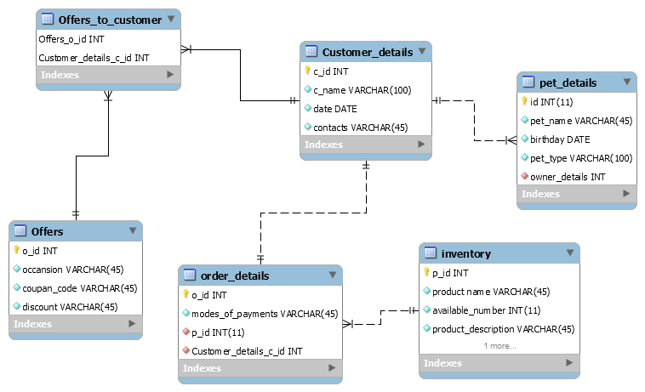

# Table details

The tables of the database contain the information about the particular things, which are given below in detail-

#### Customer_details:

This table contains the information about the customer.

CREATE TABLE IF NOT EXISTS `Customer_details` (

`c_id` INT NOT NULL AUTO_INCREMENT,

`c_name` VARCHAR(100) NOT NULL,

`date` DATE NOT NULL,

`contacts` VARCHAR(45) NOT NULL,

PRIMARY KEY (`c_id`))

ENGINE = InnoDB;

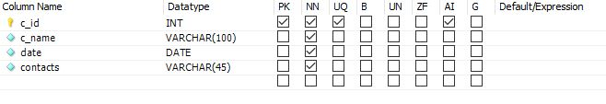

#### pet_details

This table contains the information about the pet and owner of the pet, the table contents are given below.

CREATE TABLE IF NOT EXISTS `pet_details` (

`id` INT(11) NOT NULL,

`pet_name` VARCHAR(45) NOT NULL,

`birthday` DATE NOT NULL,

`pet_type` VARCHAR(100) NOT NULL,

`owner_details` INT NOT NULL,

PRIMARY KEY (`id`),

CONSTRAINT `owner_id`

FOREIGN KEY (`owner_details`)

REFERENCES `Customer_details` (`c_id`)

ON DELETE NO ACTION

ON UPDATE NO ACTION)

ENGINE = InnoDB;

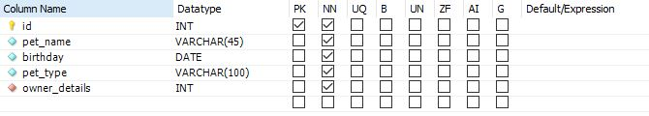

#### Inventory:

It contains information about the inventory, which is available in the store.

CREATE TABLE IF NOT EXISTS `inventory` (

`p_id` INT NOT NULL AUTO_INCREMENT,

`product name` VARCHAR(45) NOT NULL,

`available_number` INT(11) NOT NULL,

`product_description` VARCHAR(45) NOT NULL,

`price_per_piece` VARCHAR(45) NOT NULL,

PRIMARY KEY (`p_id`))

ENGINE = InnoDB;

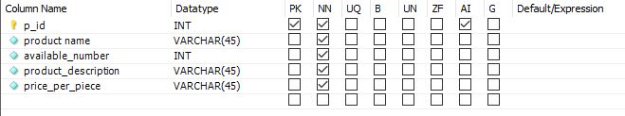

#### Order details:

It contains the information about the order proceed by the customer.

CREATE TABLE IF NOT EXISTS `order_details` (

`o_id` INT NOT NULL AUTO_INCREMENT,

`modes_of_payments` VARCHAR(45) NOT NULL,

`p_id` INT(11) NOT NULL,

`Customer_details_c_id` INT UNSIGNED NOT NULL,

PRIMARY KEY (`o_id`),

CONSTRAINT `p_id`

FOREIGN KEY (`p_id`)

REFERENCES `inventory` (`p_id`)

ON DELETE NO ACTION

ON UPDATE NO ACTION,

CONSTRAINT `fk_order_details_Customer_details1`

FOREIGN KEY (`Customer_details_c_id`)

REFERENCES `Customer_details` (`c_id`)

ON DELETE NO ACTION

ON UPDATE NO ACTION)

ENGINE = InnoDB;

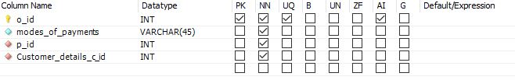

#### Offers:

It contains the information about the offer which is used for the promotion purpose.

CREATE TABLE IF NOT EXISTS `Offers` (

`o_id` INT NOT NULL AUTO_INCREMENT,

`occansion` VARCHAR(45) NOT NULL,

`coupan_code` VARCHAR(45) NOT NULL,

`discount` VARCHAR(45) NOT NULL,

PRIMARY KEY (`o_id`))

ENGINE = InnoDB;

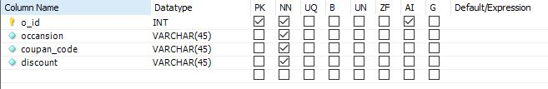

The specific requirement and testing portion are given below –

START TRANSACTION;

USE `Paw Print Factory`;

INSERT INTO `Offers_to_customer` (`Offers_o_id`, `Customer_details_c_id`) VALUES (3, 1);

INSERT INTO `Offers_to_customer` (`Offers_o_id`, `Customer_details_c_id`) VALUES (1, 2);

INSERT INTO `Offers_to_customer` (`Offers_o_id`, `Customer_details_c_id`) VALUES (2, 2);

INSERT INTO `Offers_to_customer` (`Offers_o_id`, `Customer_details_c_id`) VALUES (3, 2);

INSERT INTO `Offers_to_customer` (`Offers_o_id`, `Customer_details_c_id`) VALUES (1, 3);

INSERT INTO `Offers_to_customer` (`Offers_o_id`, `Customer_details_c_id`) VALUES (2, 4);

COMMIT;

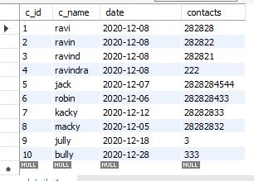

SELECT c.c_id,c.c_name, p.pet_name

FROM `paw print factory`.customer_details c,`paw print factory`.pet_details p;



START TRANSACTION;

USE `Paw Print Factory`;

INSERT INTO `order_details` (`o_id`, `modes_of_payments`, `p_id`, `Customer_details_c_id`) VALUES (1, 'Internet banking', 2, 1);

INSERT INTO `order_details` (`o_id`, `modes_of_payments`, `p_id`, `Customer_details_c_id`) VALUES (2, 'mobile banking', 4, 4);

INSERT INTO `order_details` (`o_id`, `modes_of_payments`, `p_id`, `Customer_details_c_id`) VALUES (3, 'cash', 6, 5);

INSERT INTO `order_details` (`o_id`, `modes_of_payments`, `p_id`, `Customer_details_c_id`) VALUES (4, 'card payment', 4, 2);

INSERT INTO `order_details` (`o_id`, `modes_of_payments`, `p_id`, `Customer_details_c_id`) VALUES (5, 'Internet banking', 2, 3);

INSERT INTO `order_details` (`o_id`, `modes_of_payments`, `p_id`, `Customer_details_c_id`) VALUES (6, 'mobile banking', 4, 7);

INSERT INTO `order_details` (`o_id`, `modes_of_payments`, `p_id`, `Customer_details_c_id`) VALUES (7, 'Internet banking', 2, 9);

INSERT INTO `order_details` (`o_id`, `modes_of_payments`, `p_id`, `Customer_details_c_id`) VALUES (8, 'NEFT', 8, 6);

COMMIT;



# Conclusion

With the help of a better and efficient database design, we can save lots of time and lots of space, which can be utilized in some other place to improve the productivity of the company, with the help of the efficient database we can save lots of time, we can find the required data, records such as inventory, history of the customer, contacts to the customer, etc. which will improve the productivity and profitability of the company.